Question 1:-> Difference between class and structure.

Structures | Classes
class key is struct | class key is class
Default access is public | Default access is private
No usage constraints | No usage constraints
Also, Class memory allocation is on heap, while structure has on stack.

Question 2:-> is sizeof() function working for abstract datatype?

One way of solving:
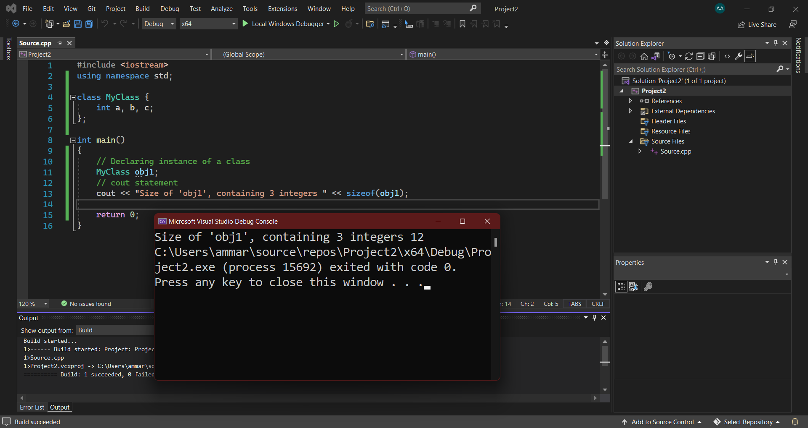

Another way of solving:
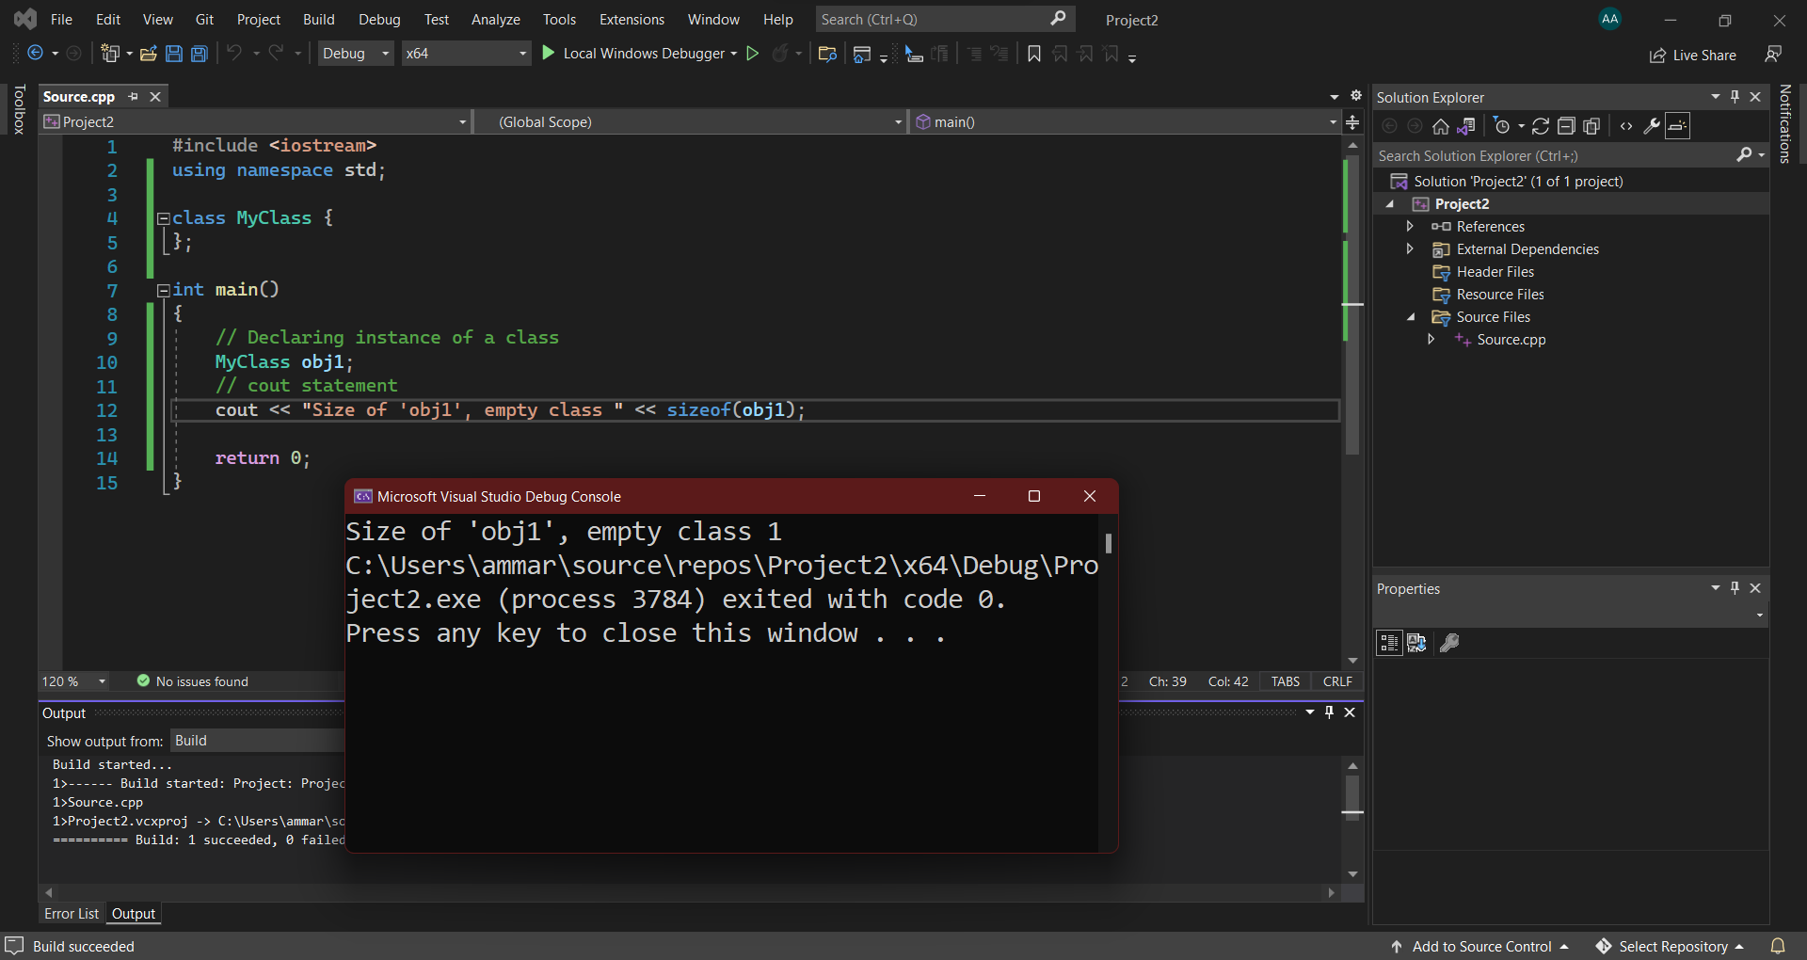

https://docs.microsoft.com/is-is/cpp/cpp/classes-and-structs-cpp?view=msvc-170&viewFallbackFrom=vs-2019

